

|  |  |
| --- | --- |
|  |  |
| Student Name: | Aagam Sanjay Shah |
| Deliverable: | Assignment 1 |
| Course Name: | [NTWK8121-24S-Sec3-SQL Serv](https://conestoga.desire2learn.com/d2l/home/1124154)er |
|  |  |
| Date Assigned: | 29/05/2024 |
| Date Due: | 09/06/2024 |
| Rules: | * Individual. * Cheating is not allowed. * Plagiarism counts as cheating! * That FAILURE to submit work in the course can result in a grade of ‘F’ or ‘I’ for failure to complete the course! |

Screenshot of SQL Domain Controller as “SQL DC Assignment1”

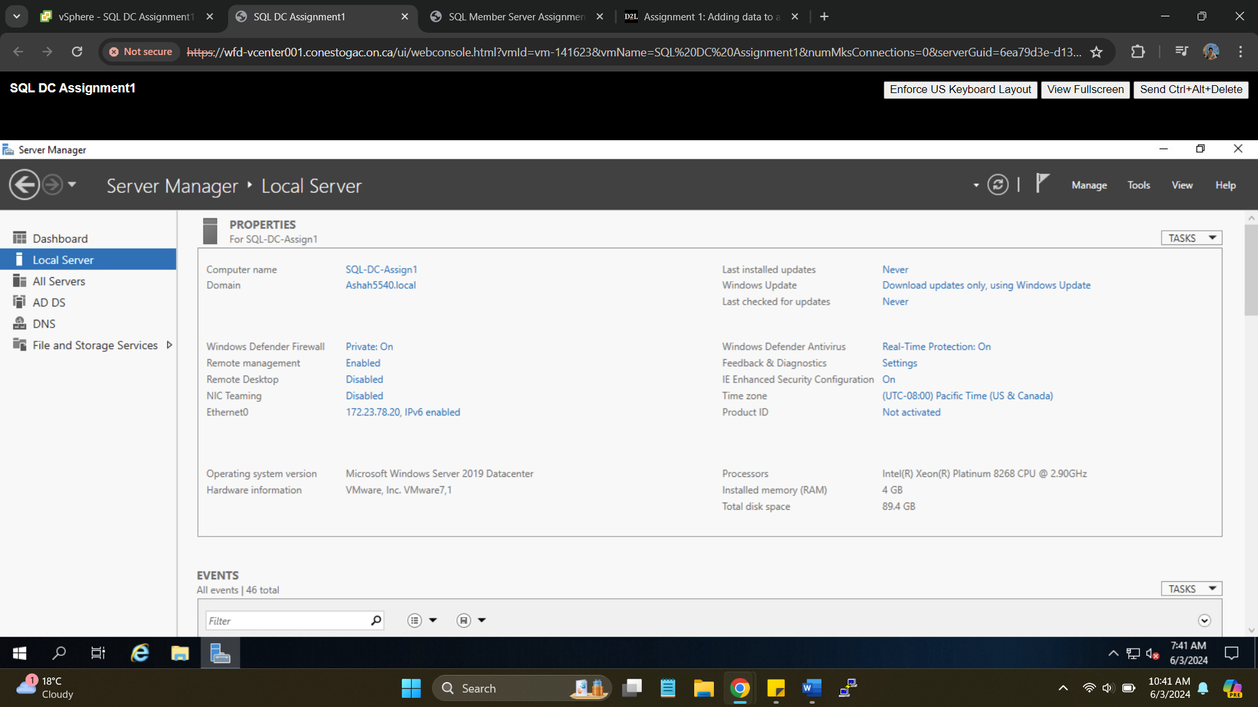

SQL Member server as “SQL-MbrSvr-Ass1”

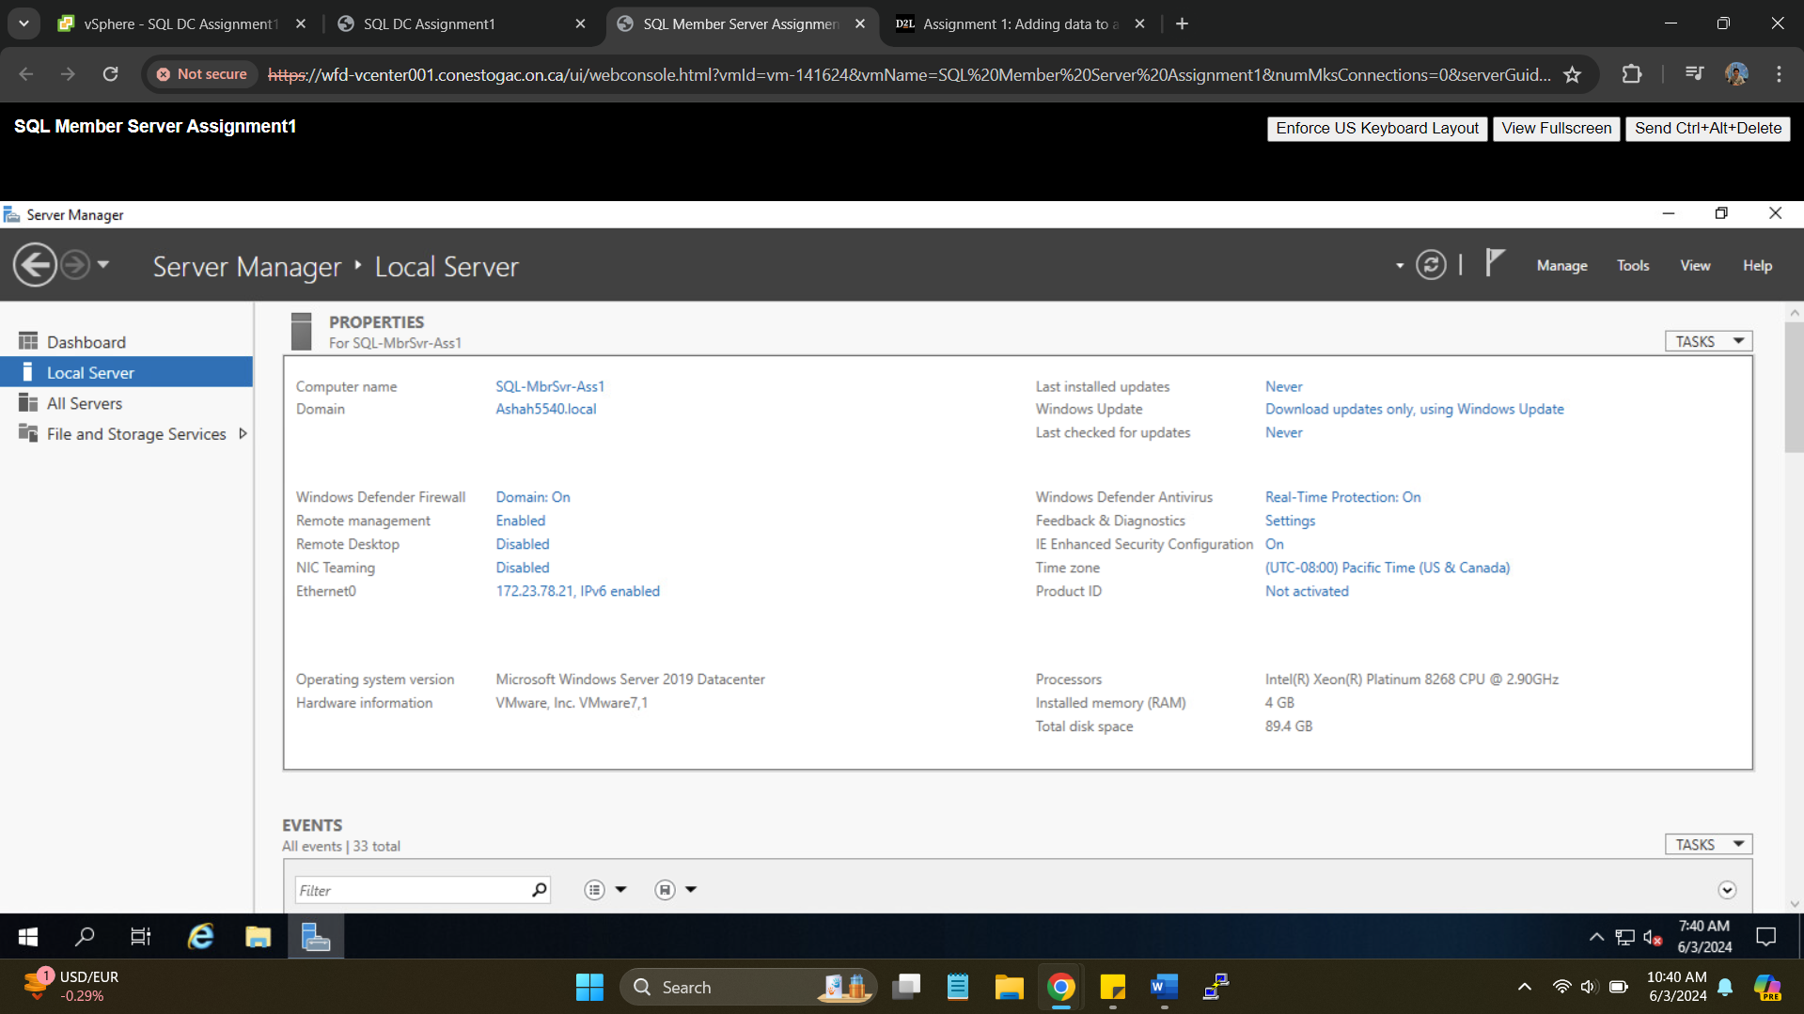

Created User 🡪 **”Aagam Shah”**

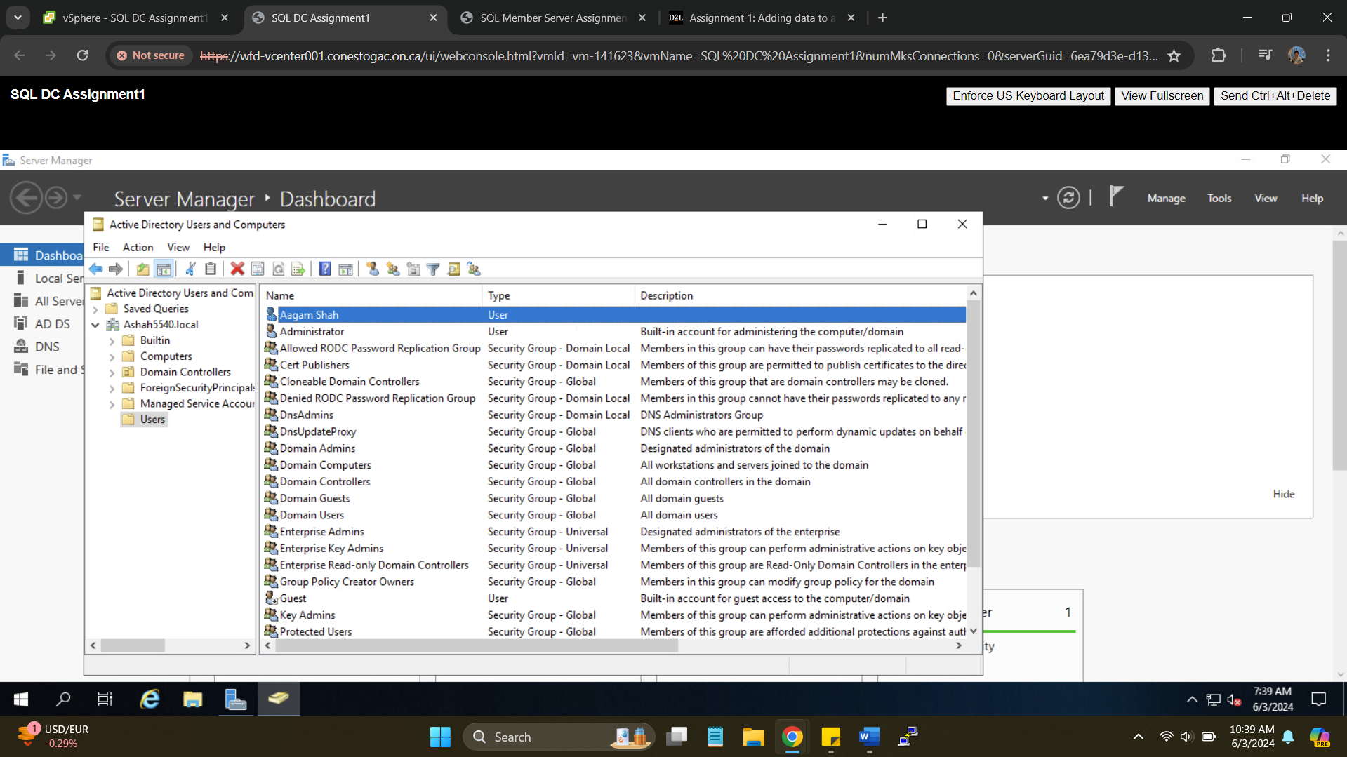

Installing SQL Server Management Studio on Member Server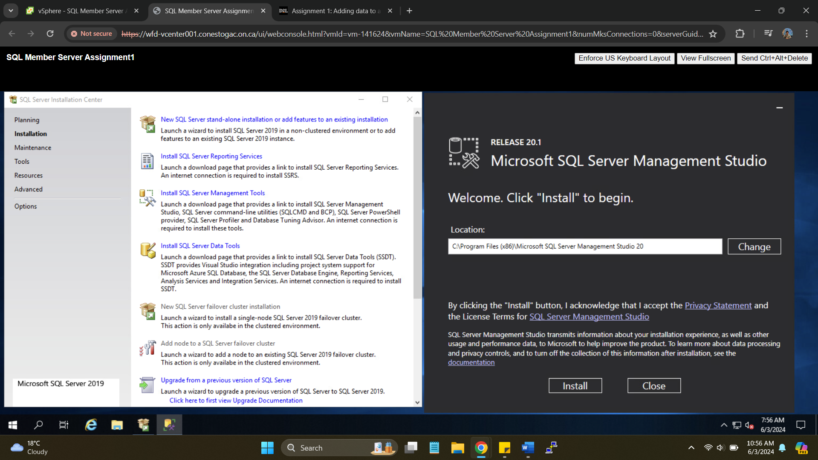

Selecting features to be installed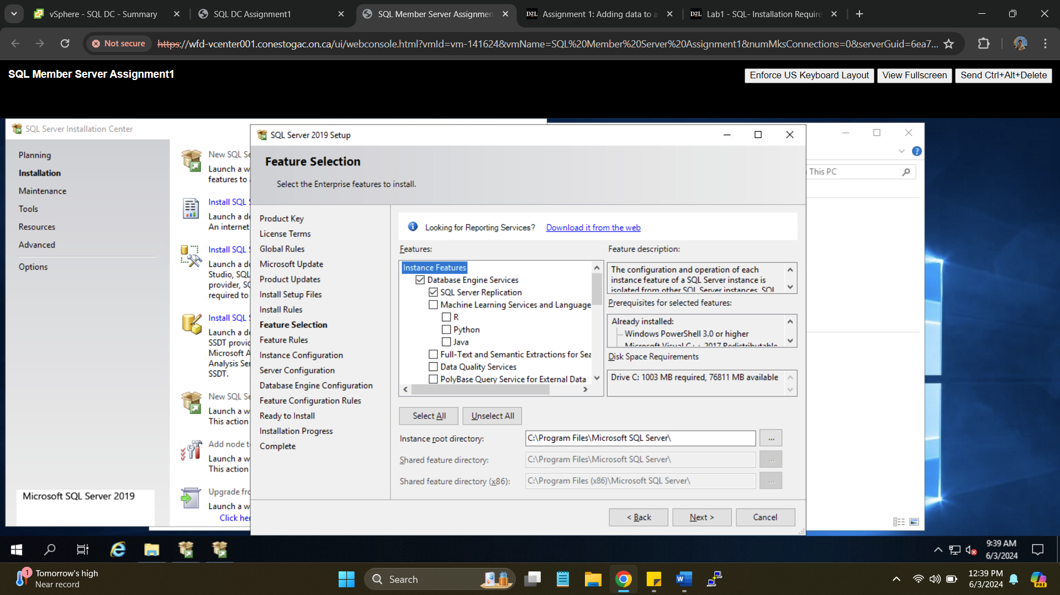

Create a new instance and call it something with your name in it and **SQLSVR2** i.e. **“Aagam_SQLSVR2”**

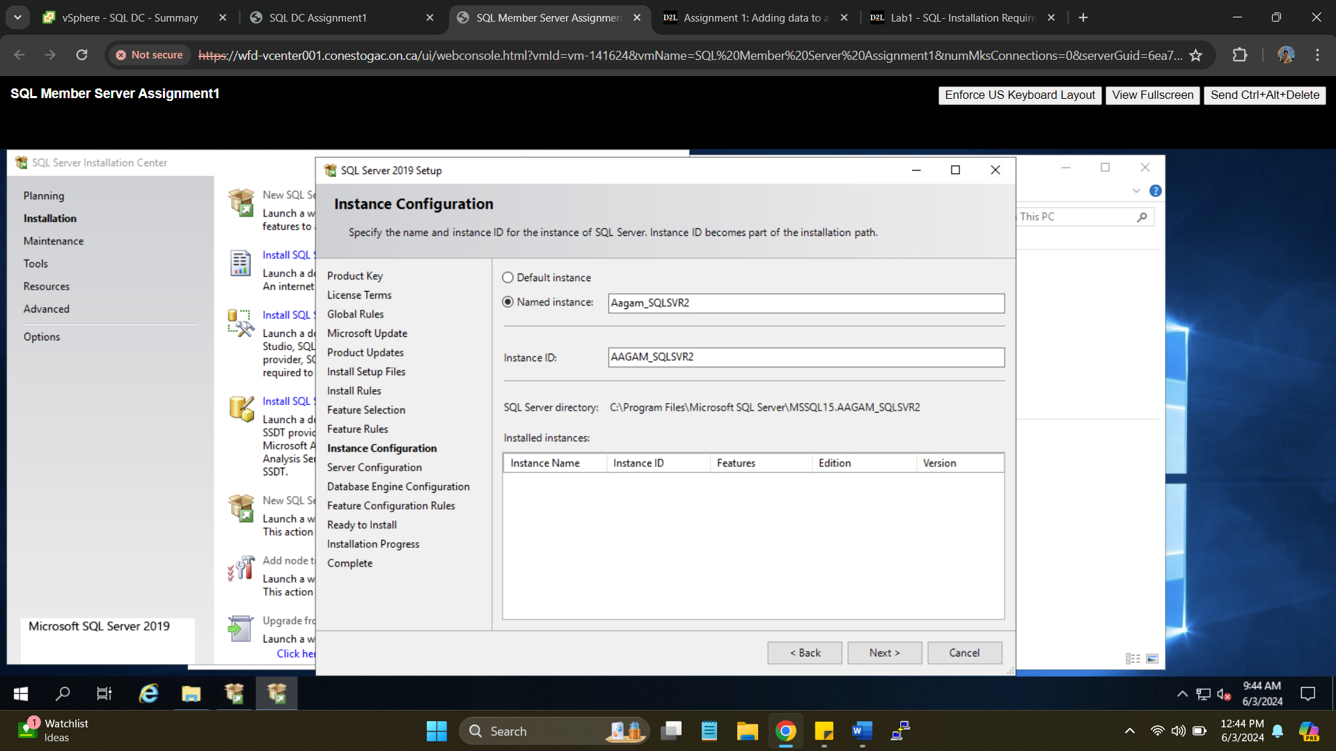

Providing password for SQL Server agent and SQL Server Database Engine as “Secret55”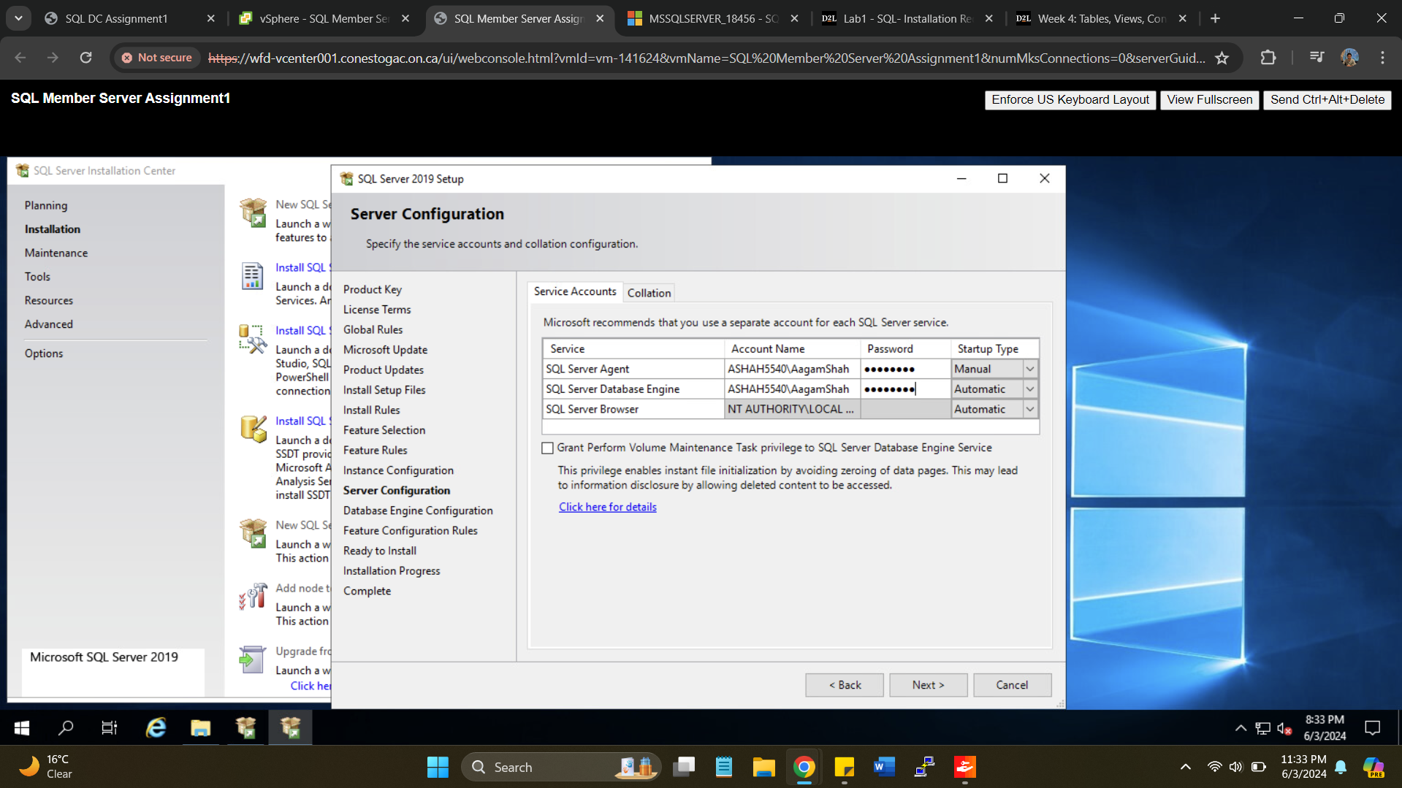

Selecting as Mixed mode and Password as “Secret55”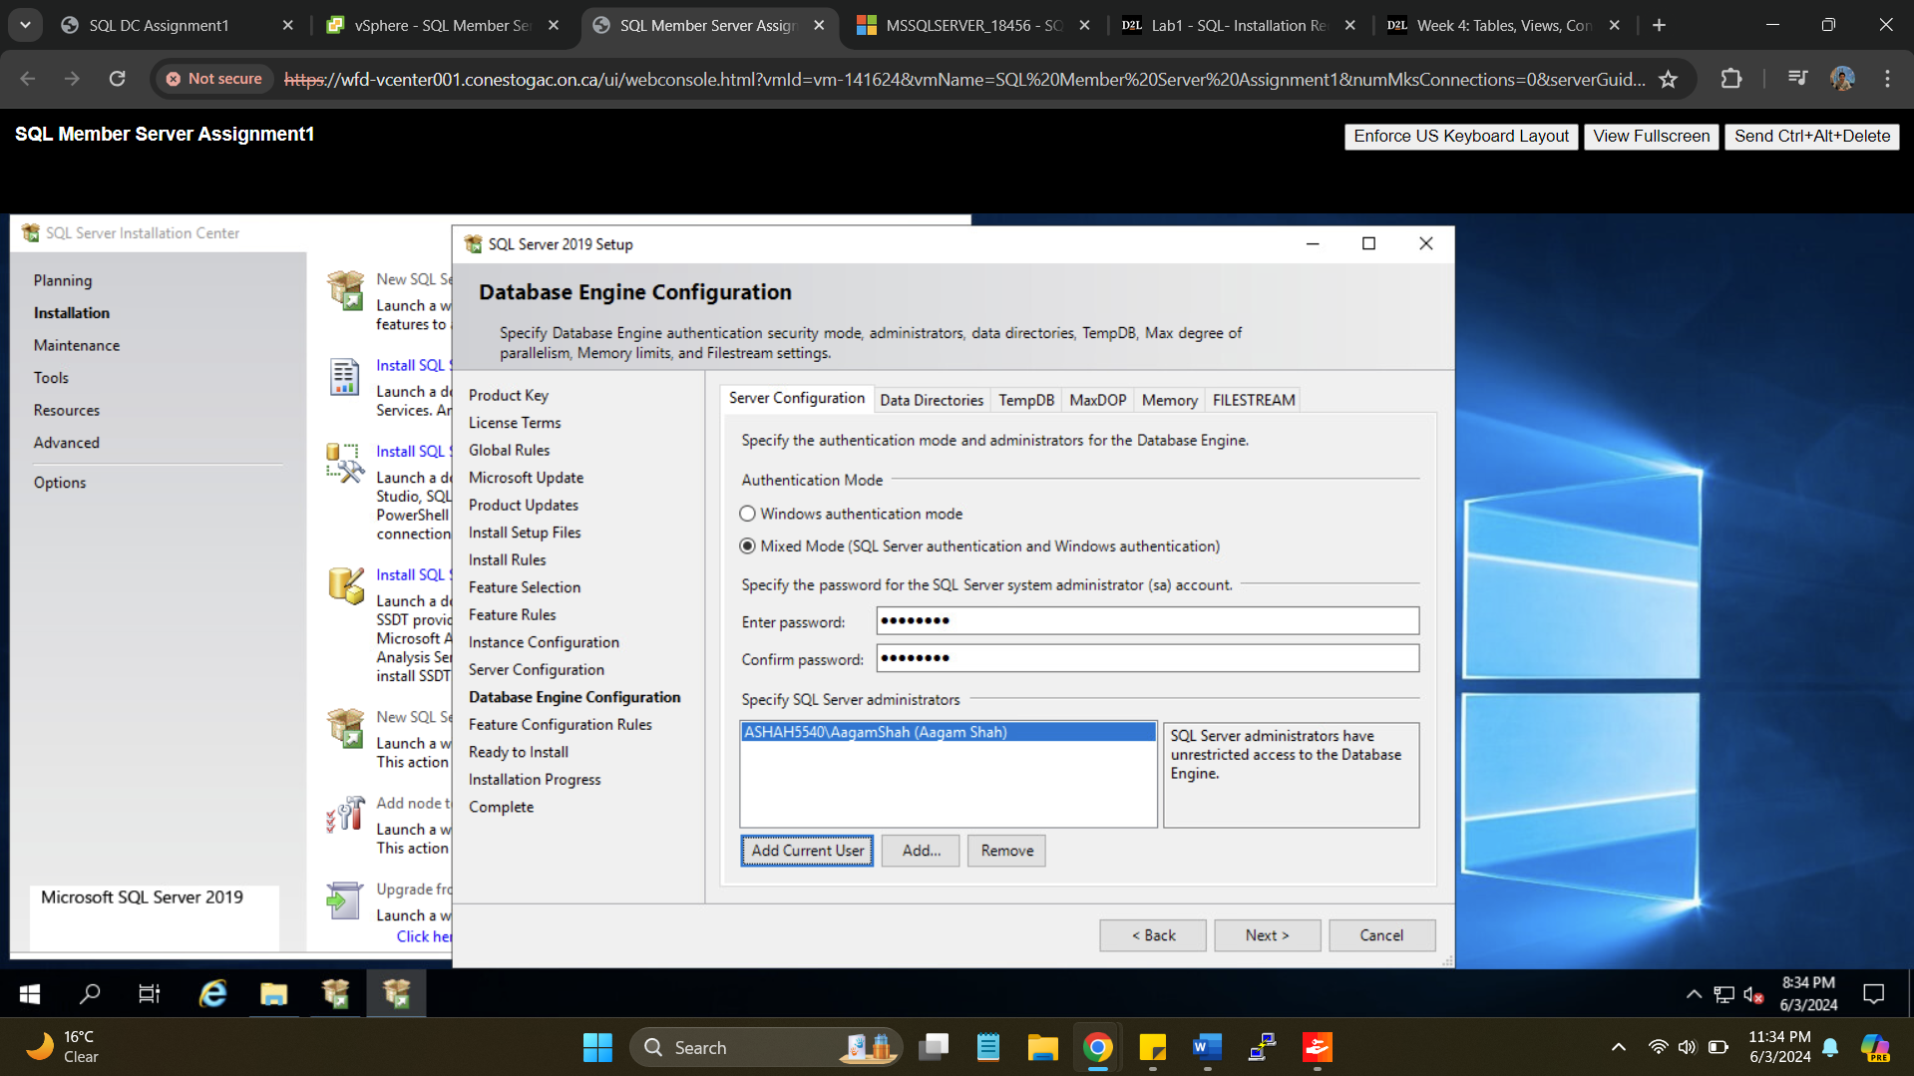

Login in with new instance “AAGAM_SQLSVR2”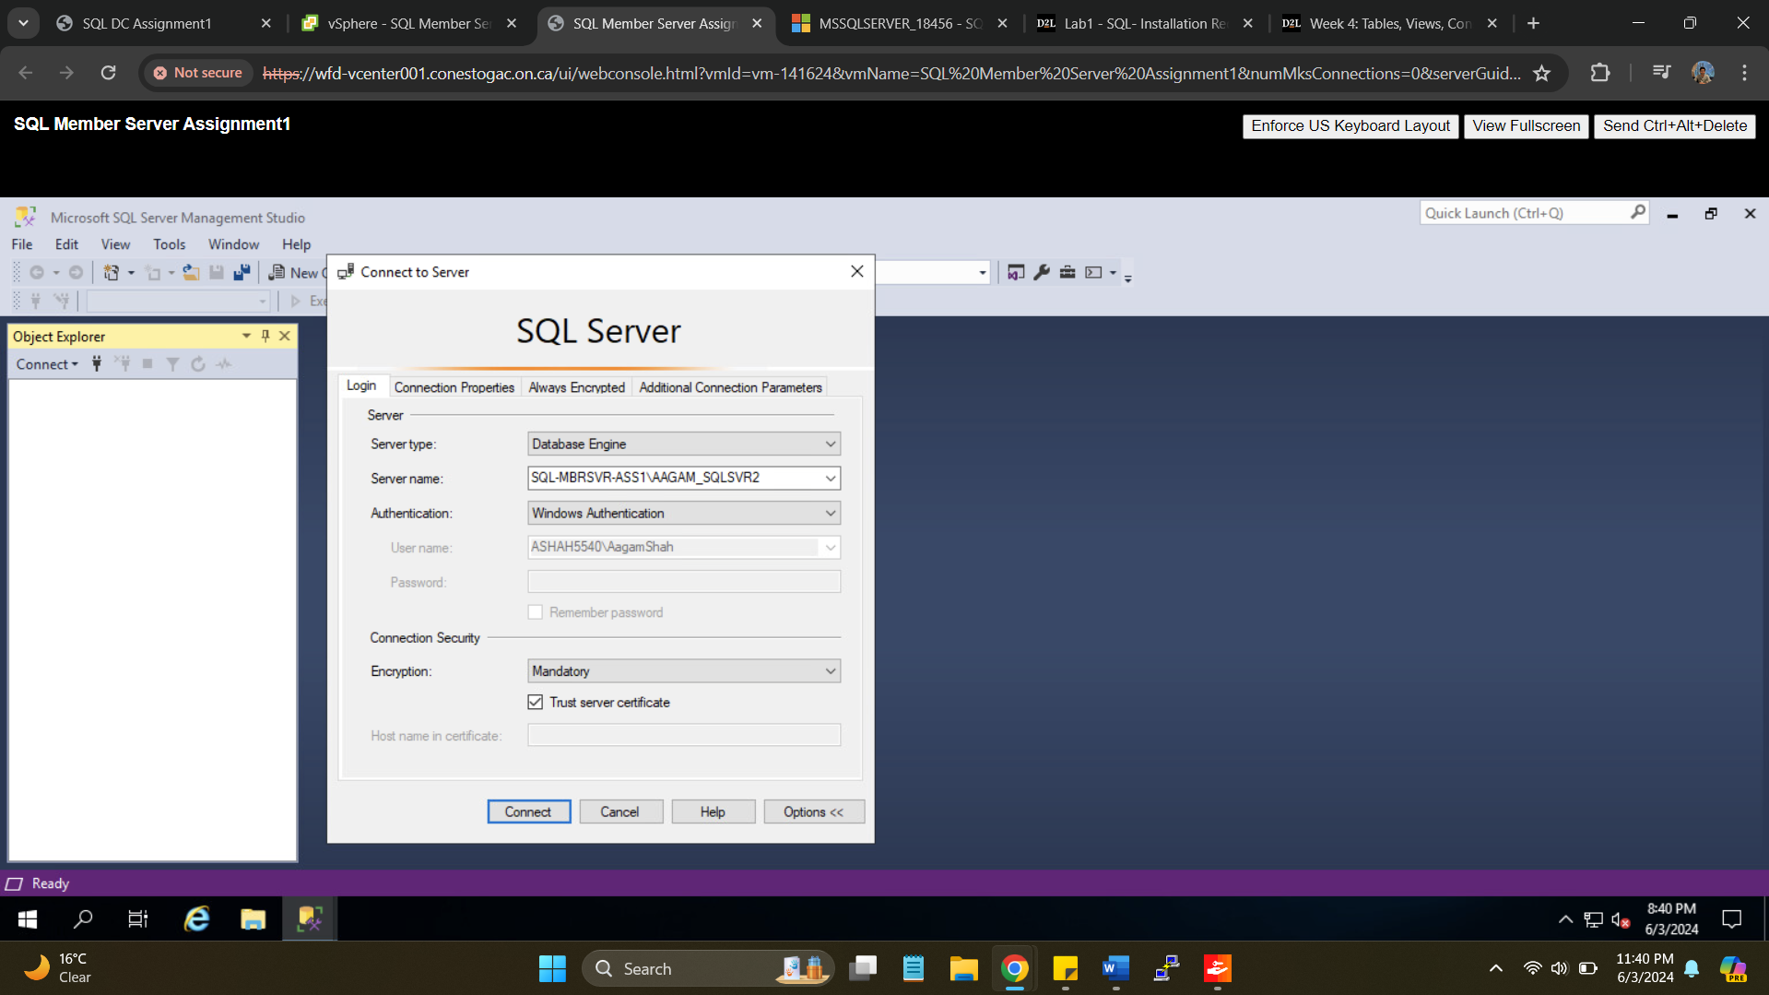

1. Provide a list of all employees, with their role in the company, their salary (job level), and the publisher that they are connected to **(*in a text file*).**



1. Provide the SQL query to run this command myself for future reporting. **(Query can be saved as .SQL file)**

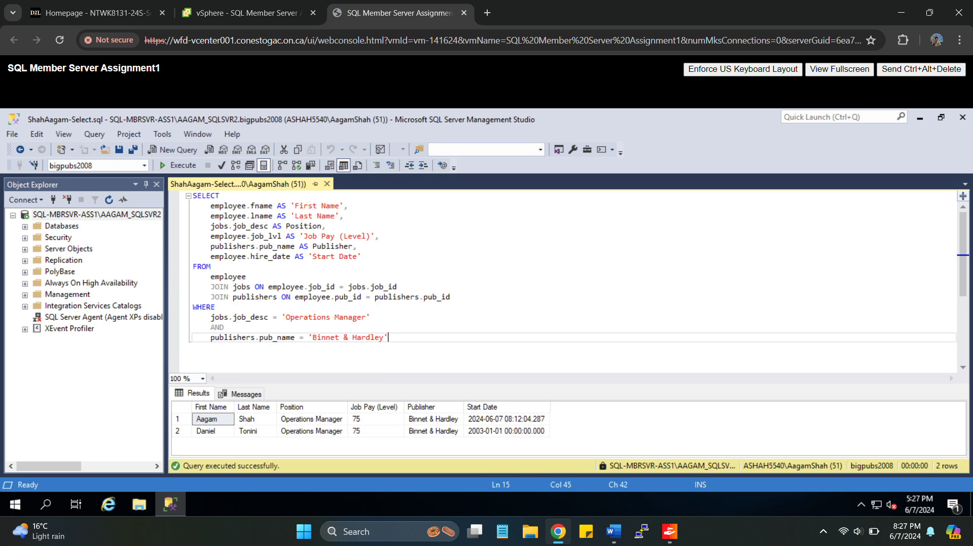

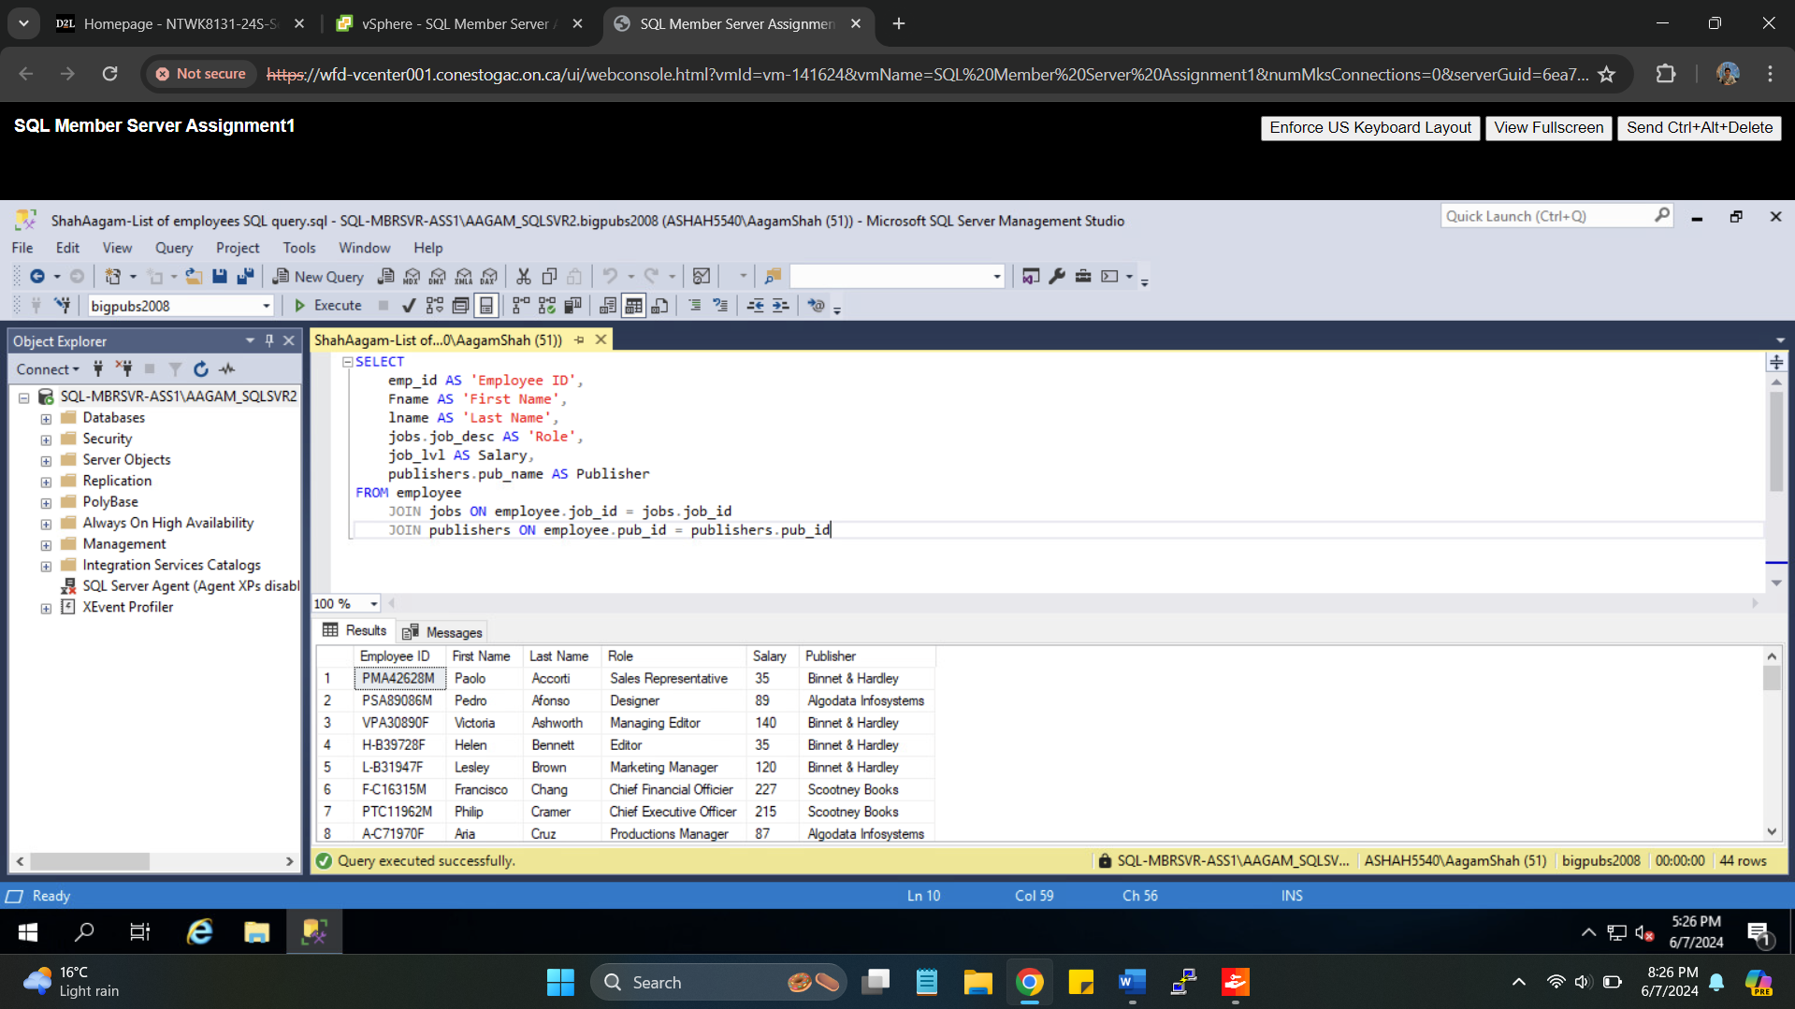

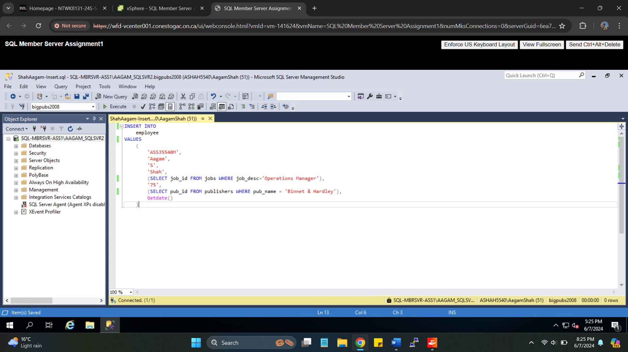

1. Provide a screenshot of the SSMS Console making sure that the Server Name & SQL Server version are fully visible

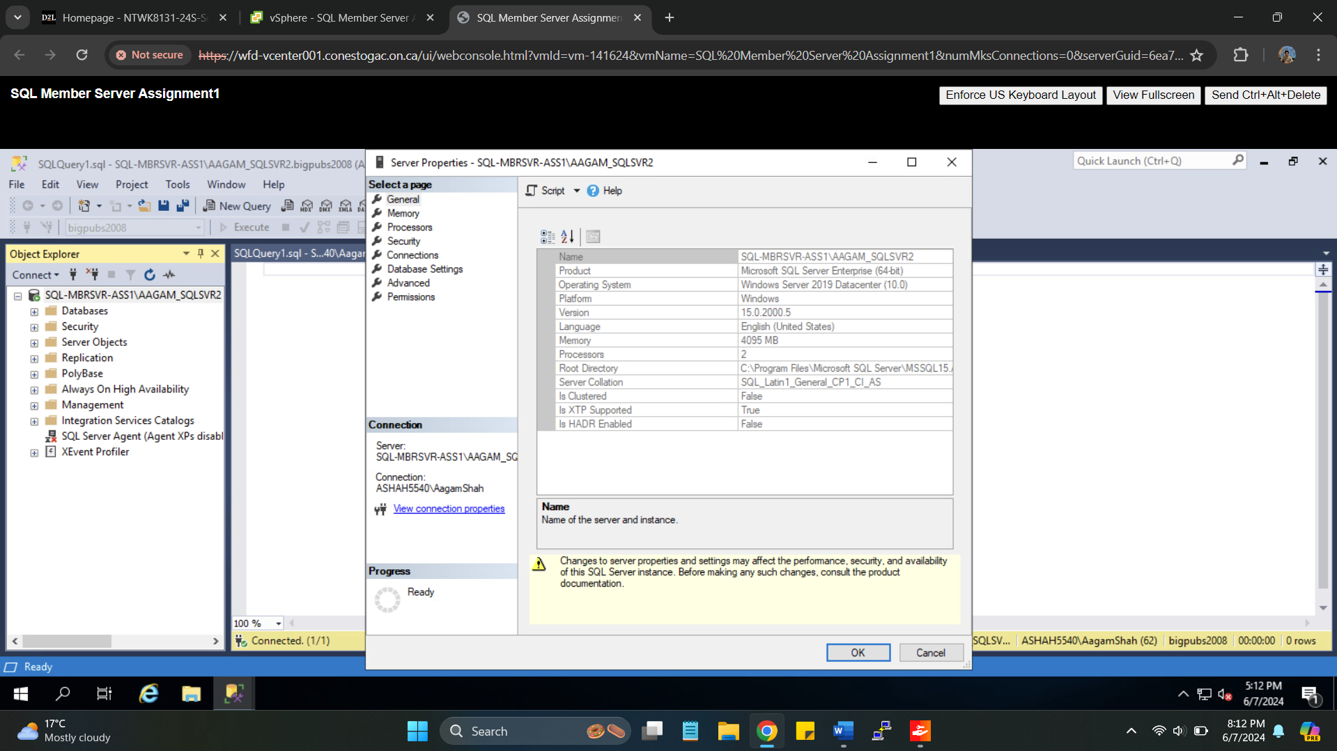

1. Screenshots of restoring database and all SQL statements execution and result

Placing backup2008.bak file for database restoration in backup folder of SQL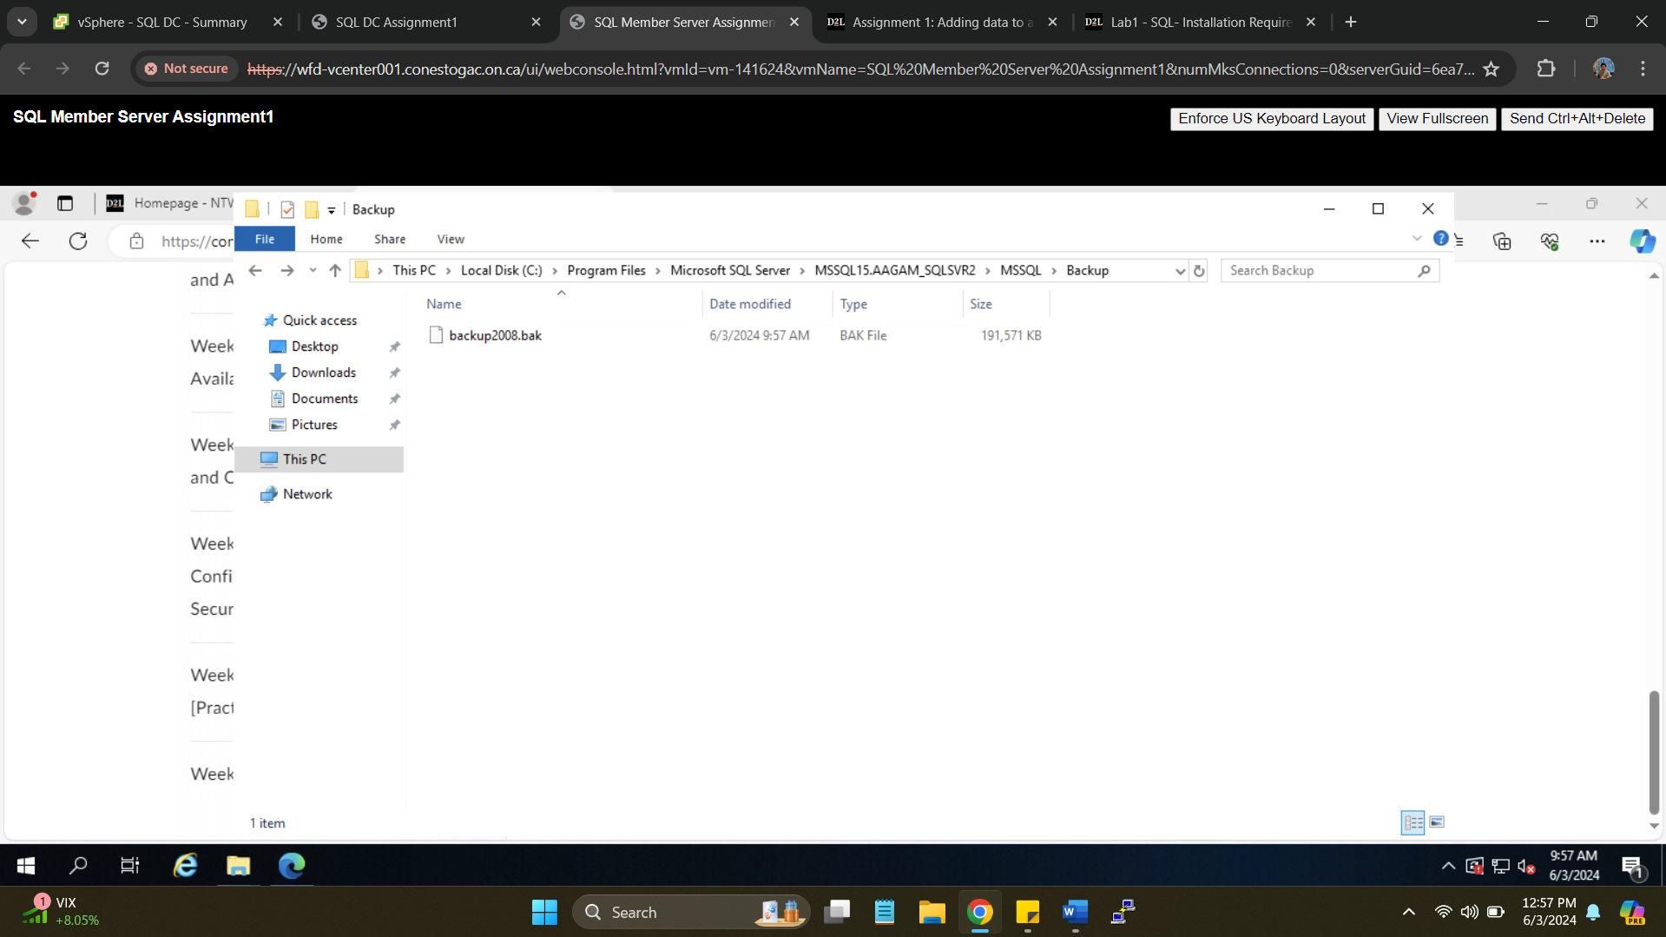

Selecting backup2008.bak file for database restoration

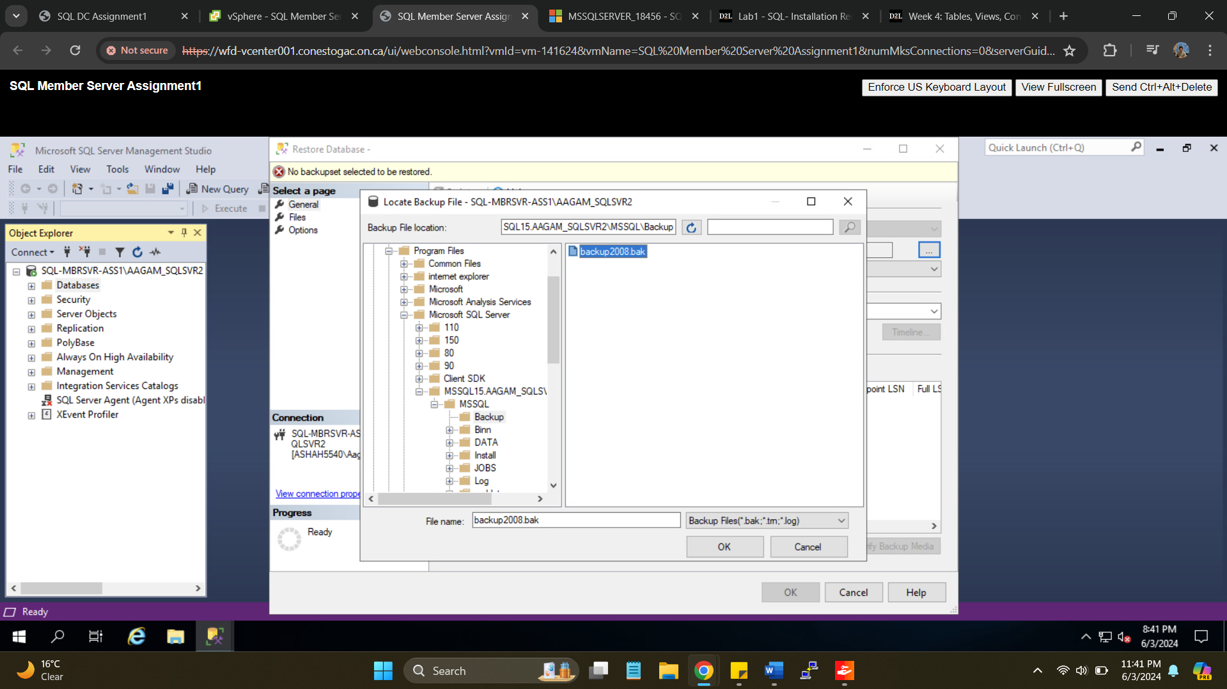

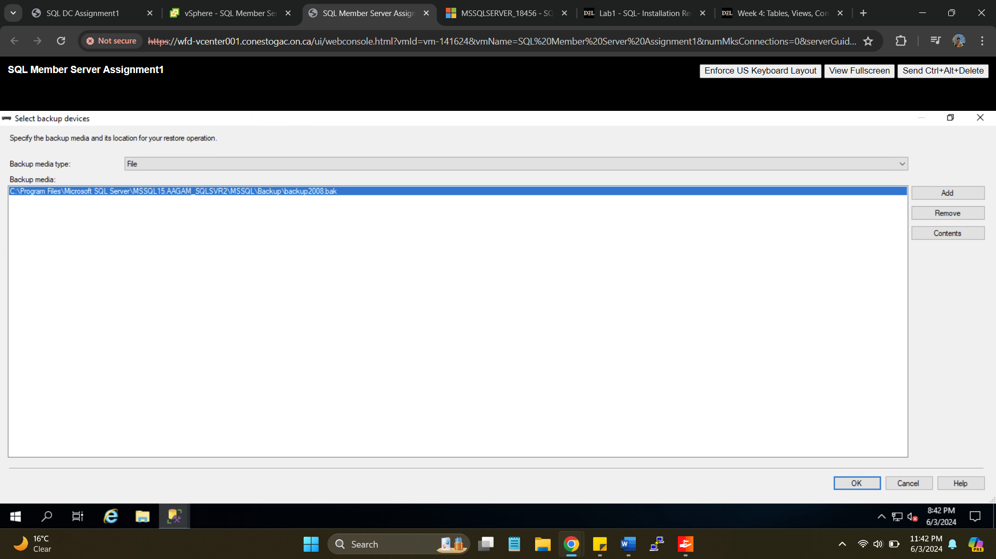

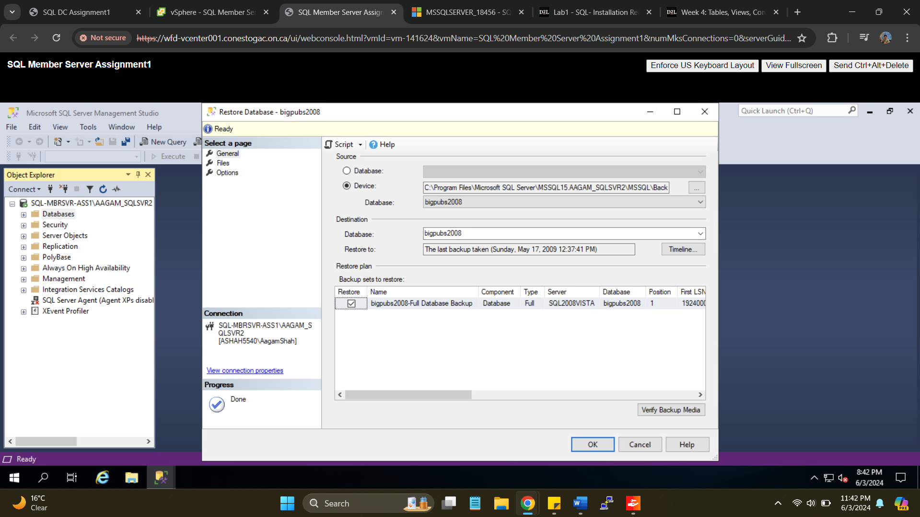

Database restore successfully.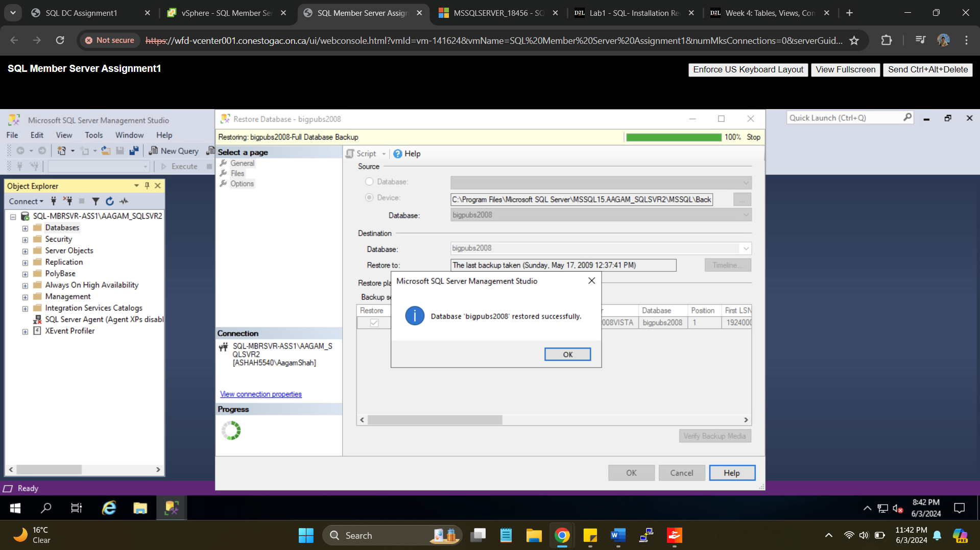

1. Provide a screenshot  of the command prompt running the following command.  Note you will need to replace <hostname> with your windows hostname:

**ping <hostname> -n1 -4**

ping SQL-MbrSvr-Ass1 -n1 -4

